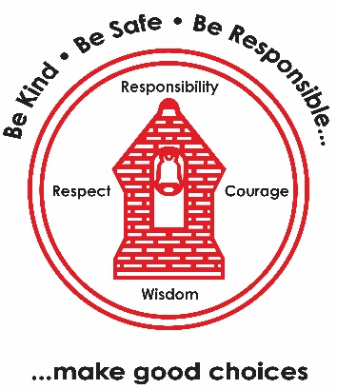
Computing – Purple Mash/Spreadsheets
- Logging in and saving work
- To understand what a spreadsheet is
- To edit and improve a spreadsheet
- To explore how spreadsheets can complete calculations automatically
- To create and interrupt block diagrams from data.
PSHE – The Empowerment Approach
- Shifting mindsets
- Brain building
- Why is sleep so important?
- What foods can help me stay healthy?
- How can I make healthy choices every day?

PE
Indoor
- Gymnastics - Linking

Outdoor
- Games for understanding – Attack and Defence
Maths
- Number
- Place Value
- Number bonds
- Add and Subtract
- Two times tables
English
- Vlad and the Great Fire of London
- Read Write Inc.
- Use question marks
- Write in the present tense
- Write in the past tense
- Use the words ‘or’, ‘and’ and ‘but’
Art – Sculpture and 3D; Clay Houses
- Exploring clay
- Pinch pots
- Applying skills in clay
- Design a tile
- Make a 3D tile
Music – Ocarinas (London’s Burning).
- Introduction and play 8 notes
- Make connections between notations and musical sounds
- Perform as piece of music
Year 2 Learning Map:
Term 1
History – The Great Fire of London

- How has London changed?
- How do people live now compared to how people lived in 1666?
- What were the key events of the Great Fire of London?
- How Do We Know About the Great Fire?
- What Happened After the Great Fire?
- What Have We Learnt about the Great Fire?
RE – Jews
- What is precious to us?
- What is precious to Jewish people?
- What is inside a mezuzah and what does it remind Jewish people about?
- How and why do Jewish people celebrate Shabbat?
Science – Uses of Everyday Materials
- Recognise that objects are made from materials that suit their uses.
- Recognise that the shape of some solid objects can be changed.
- Compare the suitability of materials for particular uses.
- Recognise that the strength of some materials can be changed.
- Compare the suitability of materials for particular uses.
- Recognise that some materials are harmful to the environment.

