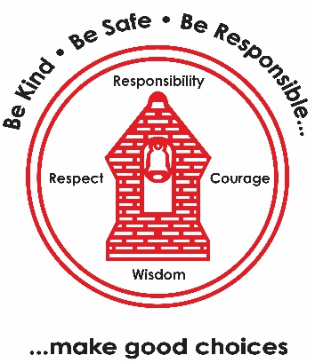
PSHE – The Empowerment Approach
- Shifting mindset
- To begin to understand our brain
- To understand what makes us feel comfortable and safe
- To understand what ‘feel good’ chemicals are
- Prep 4 Best
Computing – Quizzing
- Explore different types of quizzes
- Experiment with different types of questions
- Title screen & contents page
- To refine & test quizzes
Music – Composition Ancient Egypt
- To sing with accuracy and fluency
- To use different forms of notation
- To understand note length
- Simple pitch notation

RE– Why do some people think God exists?
- How many people believe in God?
- What do Christians think?
- What do Christians believe about how the world began?
- Why do people believe or not believe in God?
- Is God real?
Science – Mixtures and Separation
- Mixtures
- Sieving
- Filtering
- Solutions
- Dissolving
- evaporating
English
- ‘How To Train Your Dragon’ – Cressida Cowel
- Persuasive writing
- Informative reports
- Instructional writing

DT – Electrical Systems -Doodlers
- To understand how motors are used
- To put research into practice
- To develop a DIY kit to assemble
- To investigate an existing product
Maths
- Number and place value
- Addition and Subtraction
- Measures

PE
- Tag Rugby (Outdoor)
- Gymnastics: Flight (Indoor)
French – The Date
- Learn how to spell and recall the 7 days of the week
- Learn how to spell and recall the 12 months of the year
- Learn and spells numbers up to 31
- Learn how to spell the date
Learning Map:
Year 5 Term 1 2026/2027
History – Were the Vikings raiders, traders or something else?
- When and why did they come to Britain?
- Where did they go?
- Trading routes
- Viking sagas
- The impact of Viking raids
- How did they get here?

