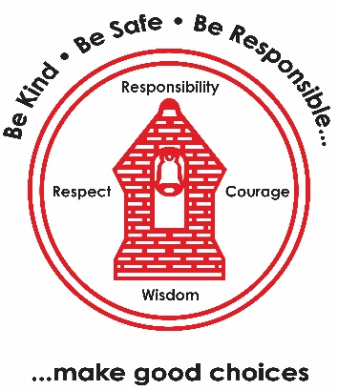
Science – Digestion and Food
• The human digestive system
• Human teeth
• Investigating dental hygiene
• Teeth of carnivores, herbivores and omnivores
• Producers, predators and prey in food chains
• Poo clues – what can it tell us?
Art – Drawing: Power Prints
• 3D pencil drawings – use tone to create a 3D effect
• Sense of proportion – explore proportion and tone when drawing
• Drawing with scissors – plan a composition for a mixed-media drawing
• Wax resist – use shading techniques to create pattern and contrast
• Power prints – work collaboratively to develop drawings into prints
RE – Why is Jesus inspiring to some people?
• What does 'inspiring' mean and who is inspiring?
• What do we know about Jesus' life story and is it inspiring for some people?
• Was Jesus inspiring because of his actions?
• What did Jesus teach? Was he a good and inspiring teacher?
• Did Jesus' teachings inspire people? How and why?
• Who did Jesus say he was and why is this important to Christians?
Music – Ukulele
• Know how to hold and strum a ukulele
• Strum notes on a ukulele
• Know the order of strings on a ukulele
• Play a song using the C chord
• Learn the G chord and play it in a song
History – How have children's lives changed?
• Use sources to identify how children's lives have changed
• Understand why Tudor children worked and what their working conditions were like
• Understand the jobs Victorian children had and their working conditions
• Understand how Lord Shaftesbury changed children's lives
• Understand how and why children's leisure time has changed.
PSHE – The Empowerment Approach
• Shifting mindset: understanding how our needs can be met
• Brain building: naming and understanding our 5C needs
• How can being active help my mind and body?
• How can I get support for myself or others?
• How can I respond when things feel hard?
• Know your strengths: understanding our own strengths
French – Vegetables
• Recognise, recall and spell five different vegetables
• Recognise, recall and spell a further five vegetables
• Consolidate all ten vegetables
• Use 'I would like' plus a quantity of various vegetables
• Use the conjunction 'and'
• Supplementary: months of the year
PE
• Tag Rugby (outdoor)
• Gymnastics: Levels and Direction (indoor)
English
- Reading fluency
- Complete Comprehension skills.
- WRITER - The Lighthouse (short film)
- Setting description
- Recounts
- Diary entries
Computing – Effective Searching and Introduction to AI
• Understand what a search engine is and use simple keywords to find information online
• Understand how search engines collect, sort and rank results
• Use advanced search strategies to find accurate and useful results
• Judge whether online information is true and whether sources can be trusted
• Understand what Artificial Intelligence is and some tasks it can carry out
• Write clear and precise prompts to communicate effectively with AI tools
• Learn how to be a good digital citizen when using AI
Maths
- Arithmetic skills
- Revision of 3x tables
- Learning 9x tables
- Place Value up to 4-digit numbers.
- Rounding to the nearest 10, 100 or 1000.
- Roman Numerals
Learning Map:
Year 4 Term 1 2026/267

