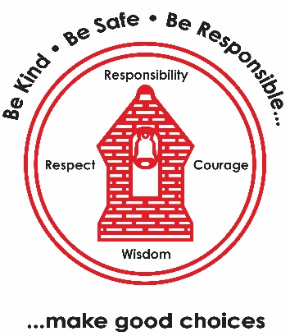
PE
- Gymnastics: cannon and unison (indoor)
- Tag Rugby (outdoor)

Wednesday PE Kit
Music – Ballads
- What is a ballad?
- Performing a ballad
- The story behind the song
- Writing lyrics
- Performing our song
PSHE – The Empowerment Approach
- Shifting mindset
- Being at our brain best
- How do emotions affect our bodies
- How are our minds and body connected?
- What can I do when I have strong emotions?
- Know your strengths
Maths
- Place value up to three digits
- Comparing three-digit numbers
- Adding and subtracting 10 and 100
- Beginning to use the column method
- Missing numbers on a number line
Computing – Email
- How do people communicate
- Understand and respond to an email
- Compose and send an email
- Send an attachment with an email
- Learn how to use email safely
- TTRS practise
French – I am learning French
- Introduction to French
- Learn how to use greetings
- Ask ‘what is your name?’
- Recognise, recall and spell 10 different colours
- Now Press Play - Greetings
English
- Class Story – Hodgeheg by Dick King-Smith
- WRITER – Hodgeheg
Character description (Max)
Recount of a journey
Oracy – History debate ‘Would you prefer to live in the Stone Age, Bronze Age or Iron Age?
DT – Mechanical systems: Making a slingshot car
- Food around the world
- Cutting and peeling
- Tasting seasonal ingredients
- Making a mock up dish
- Evaluate the dish
History – Would you prefer to live in the Stone Age, Bronze Age or Iron Age?
- How long ago did prehistoric man live?
- What does Skara Brae tell us about the Stone Age?
- Who was this Bronze Age man?
- What was the impact of bronze in prehistoric Britain?
- How did trade change lives in the Iron Age?
RE– What is prayer?
- What is prayer? Is prayer helpful?
- How and why do Muslims pray in various ways?
- What do Muslim children say about prayer?
- How and why do Christian children pray?
- How do Muslims pray and worship at home and in the Mandir?
- What is precious and how do you say thank you?
Science – Animals: Movement and Nutrition
- Skeletons
- The bones in our body
- Muscle and movement
- Eating for survival
- Nutrient groups
- Balanced diets
Learning Map:
Year 3 Term 1 2026/27

