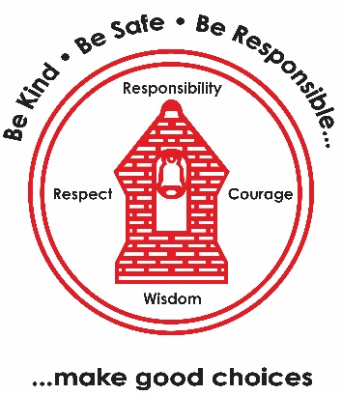
Maths
- Multiplication.
- Shapes.
- Division.
- Time.

RE– Key festivals
- 3 prayers
- Does reflection matter?
- Why do people pray?
- What have we learnt from Christians, Hindus and Muslims about prayer symbols and worship?
Music – Recorders
- Holding a recorder.
- Playing a note.
- Using a variety of blowing strengths to make notes.
PE
- Gymnastics (indoor)
- Hockey (outdoor)
Science – Forces and magnets.
- Push pulls and twists.
- Friction.
- Properties of magnets
- Uses of magnets.
Geography – Why do people live near volcanoes?
- Layers of the earth.
- How mountains are formed.
- How and where do volcanoes occur?
- Effects of volcanic eruption.

French – Adjectives
- To recognise and name colour words.
- Describe shapes by their size and colour.
- Recognise cognates.
- Follow instruction in French.
Art– Growing artists
- See like an artist.
- Recognise how artists use shape in drawing.
- Shading.
- Creating tone and texture.
- Botanical drawing.
Computing – Online safety & spreadsheets
- Passport protection.
- Fake news.
- Websites.
- Understanding spreadsheets.
PSHE – Family and relationships.
- Healthy families.
- Friendship conflict.
- Bullying.
- Effective communication.
- Respecting differences.
English
Georges Marvellous Medicine (Roald Dahl)
  - Information leaflet
  - Instructions
  - Oracy – Presentation

Learning Map:
Year 3 Term 2 2025/26

